**Experimental and numerical investigation of the hydrogen embrittlement behaviour under different stress states**

B. Nguyen1* , J. Lian1

1 Materials to Products, Department of Mechanical Engineering, Aalto University, 02150 Espoo, Finland

*binh.nguyen@aalto.fi

It is significantly important for engineers to thoroughly understand the effects of hydrogen embrittlement (HE), which causes metals to fracture prematurely compared to conditions without hydrogen-induced environment. Even though HE has immense implications in diverse engineering applications from oil, gas to hydrogen storage and transport [1], HE itself is a complex process and cannot be easily simulated. Our current understanding is that hydrogen diffusion does not significantly affect the material’s flow curve, but mostly on the fracture strain [2]. Therefore, our central aim is to develop the hydrogen embrittlement-aware fracture model under different stress states, with comprehensive understanding of HE mechanism like Hydrogen-Enhanced Localized Plasticity (HELP) and Hydrogen-Enhanced Strain-Induced Vacancy (HESIV) as a physical basis [3]. Currently, one of the contending fracture models is the extended Bai-Wierzbicki model [4], which proposes a ductile fracture criterion where the fracture strain is a function of the stress triaxiality and the Lode angle [2]. Our goal is to further build on this eMBW with Hill48 yield criterion [5] to account for HE, such as incorporating hydrogen concentration and plastic strain rate to explain the fracture strain location. After model development, the constitutive parameters are calibrated from experimental fracture tensile tests, which covers a wide range of stress states with positive stress triaxiality and Lode angle, such as smooth dog bone (SDB), notched dog bone (NDB), central hole (CH) and shear geometry (SH). The whole parameter calibration process is automated from start to finish, using simulation database generation and machine learning based methods for linking the relationship between the ductile fracture parameters and the fracture displacement. We would demonstrate that our new fracture model can capture the fracture points of all stress states with and without hydrogen charging, completing the physical explanation for fracture mechanism. In brief, our work highlights the development of the hydrogen aware fracture model and the automated process for parameter calibration, which is of great potential for further understanding of HE mechanism in metals.

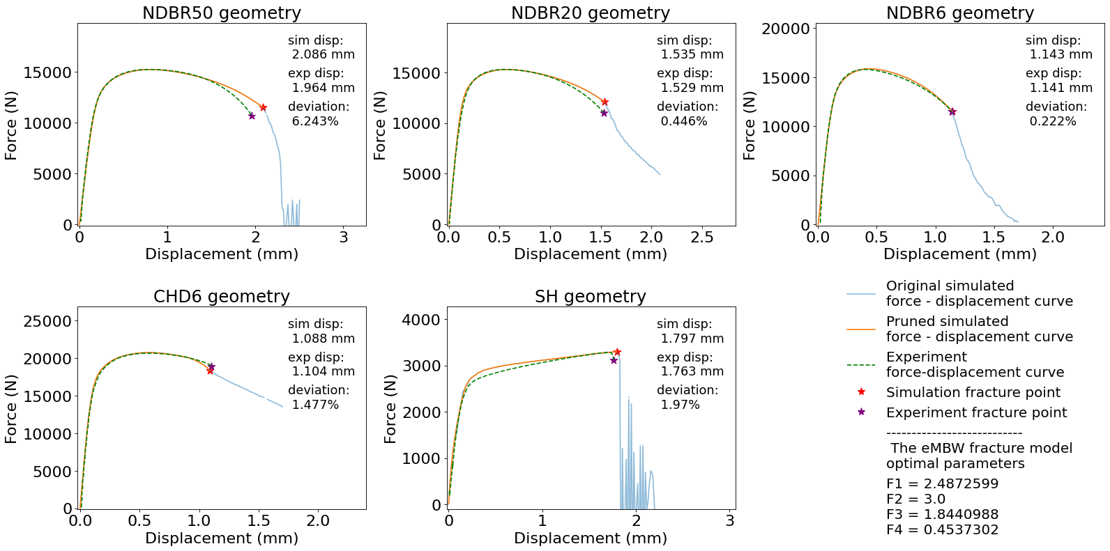

**Figure 1.** Example result: optimal parameter calibration for the eMBW fracture model   
with regards to different stress states of DP1000 steel (no hydrogen charging)

**References**

[1] Gobbi, G., et al. Advances in Engineering Software, **2019**. 135: p. 102673

[2] Alric, L.; Pluvinage, G.; Capelle, J. Preprints 2024, 2024010446

[3] Depraetere, R., W. De Waele, and S. Hertelé. Computational Materials Science, **2021**. 200. p. 110857

[4] Wu, B., et al. Fatigue & Fracture of Engineering Materials & Structures, **2017**. 40(12): p. 2152-2168.

[5] Z. Li, Y. Chang, J. Rong, J. Min, J. Lian, IOP Conference Series: Materials Science and Engineering, **2023**. 1284: p. 012021